# Practical No. 8

|  |
| --- |
| **Objective(s):**  To familiarize the students with SQL Joins |
| **Outcome:**  The students will be able to understand the requirement of Joins in DBMS |
| **Problem Statement:**  Implement the natural join, inner join and outer join. |
| **Background Study:**      A JOIN clause is used to combine rows from two or more tables, based on a related column between them.  Here are the different types of the JOINs in SQL:   * (INNER) JOIN: Returns records that have matching values in both tables * LEFT (OUTER) JOIN: Returns all records from the left table, and the matched records from the   right table   * RIGHT (OUTER) JOIN: Returns all records from the right table, and the matched records from   the left table   * FULL (OUTER) JOIN: Returns all records when there is a match in either left or right table Syntax:   SELECT Table1.attribute_name, Table2. attribute_name FROM  Table1  JOIN Table2 ON Table1.Common_attribute_name = Table2. Common_attribute_name; |

|  |
| --- |
| **Query (Student Work Area):**     1. Display all the employee name and the city where they work. 2. Display the employee name and company’s name having salary more than 15000. 3. Find the average rating and age of all sailors. 4. List various products available. 5. Display the names of salesman who have salary more than 2850. 6. Change the cost price of Trousers to 950 7. List all the clients having “a” as a second character in their names. 8. List all the products whose QtyonHand is less than Reorderlvl. 9. Print the description and total qty sold for each product. 10. Find out all the products which have been sold to “Ivan Bayross”. 11. Find the names of all clients who have purchased Trousers. 12. Find the products and their quantities for the orders placed by client C00001 and C00002. 13. List the client details who place order no. O19001. 14. List the name of clients who have placed orders worth Rs. 10000 or more. 15. Find the total of Qty ordered for each Order. |
| **Output (Student Work Area):**   1. **Display all the Employee name and the city where they Work.**  **Syntax:** select Emp_name,City from Employee;        1. **Display all the Employee name and Company’s name having Salary more than 15000.**    **Syntax:** select Emp_name,Cmp_name from Work where Salary>15000;    **3) Find the average rating and age of all sailors.**   **Syntax:** select avg(Rating),avg(Age) from Sailors; |

**4)**

**List various products available.**

○

**Syntax:**

select Dscr from Product;

**5)**

**Display the names of salesman who have salary more than 2850.**

○

**Syntax:**

select Name from Salesman where Amt>2850;

**6)**

**Change the Cost price of trouser to 950.**

○

**Syntax:**

update product set Cost_price = 950 where Dscr= ‘Trousers’;

**7)**

**List all the Clients having “a” as a second character in their names.**

○

**Syntax:**

select Name from client where Name like ‘_a%’;

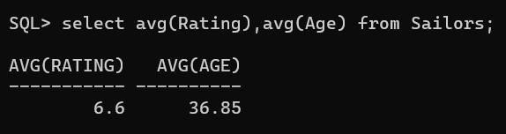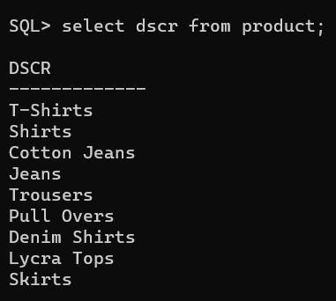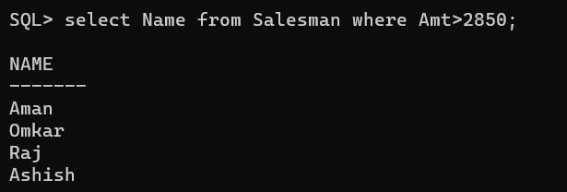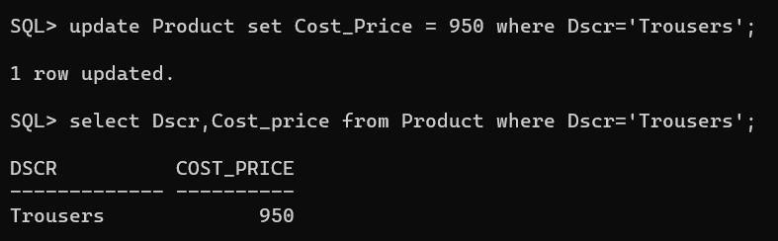

**8)**

**List all the products whose QtyonHand is less than Reorderlvl.**

○

**Syntax:**

Select Dscr From Product where Qty<Reorder_LvI

;

**9)**

**Print the description and total qty sold for each product.**

○

**Syntax:**

select P.Dscr,sum(S.Qty_order) Total_Order from Product P,

Salesorder_DetaiIs S where P.Pr_no=S.Pr_no group by P.Pr_no,P.Dscr;

**10)**

**Find out all the products wh**

**ich have been sold to "Ivan Bayross".**

○

**Syntax:**

select P.Dscr from Client C, Product P, Salesorder S,

Salesorder_DetaiIs O where and P.Pr_no=O.Pr_no and O.Od_no=S.Od_no

and C. Name='lvan Bayross' ;

**11)**

**Find the names of all clients who have pur**

**chased Trousers.**

○

**Syntax:**

select C.Name from Client C, Product P, Salesorder S,

Salesorder_DetaiIs O where and P.Pr_no=O.Pr_no and O.Od_no=S.Od_no

and P.Dscr= ‘Trousers’ ;

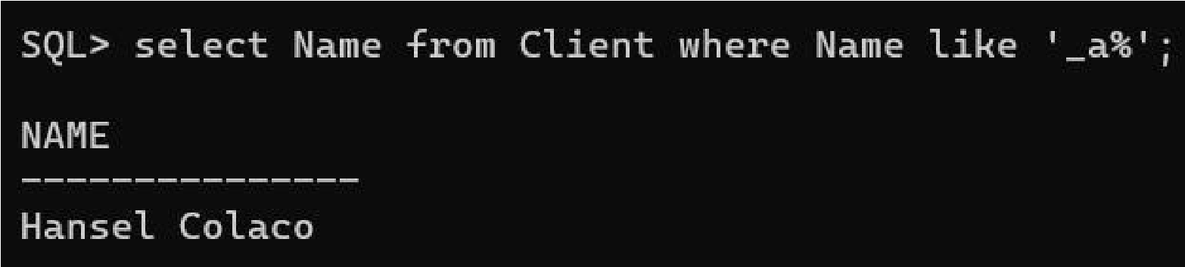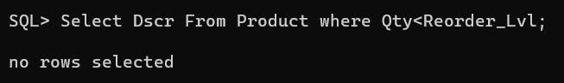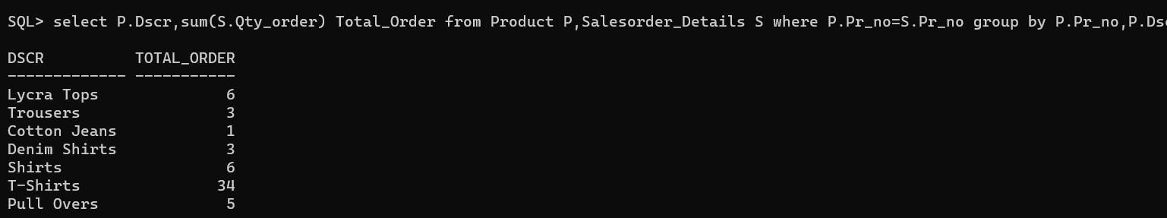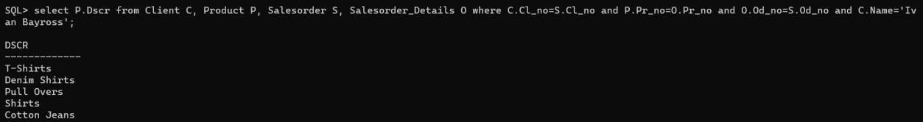

**12)**

**Find the products and their quantities for the orders placed by client**

**C00001 and C00002.**

○

**Syntax:**

select distinct Total_Oty_Order from Product P, Salesorder S,

Salesorder_DetaiIs O where P.Pr_no=O.Pr_no and O.Od_no=S.Od_no and

or group by P.Dscr,P.Pr_no,S.CI_no;

**13)**

**List the client details who place order no. 019**

**001**

**.**

○

**Syntax:**

select C. * from Client C, Satesorder S where C.Cl_no=S.Cl_no

and S.Od=’ 019001'

**14)**

**List the name of clients who have placed orders worth Rs. 10000 or**

**more.**

○

**Syntax:**

select distinct C. Name from Client C, Satesorder S,

Sates

order_DetaiIs O where and S.Od_no=O.Od_no and C.Cl_no=S.Cl_no

and (O.Qty_Order*O.Rate)>10000;

**15)**

**Find the total of Qty ordered for each Order.**

○

**Syntax:**

select Od_no, from Salesorder_DetaiIs group by Od_no;

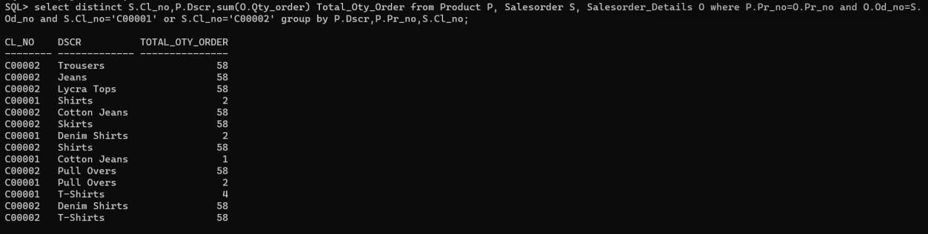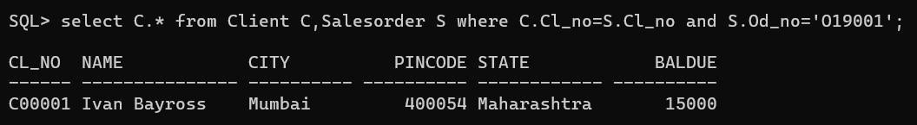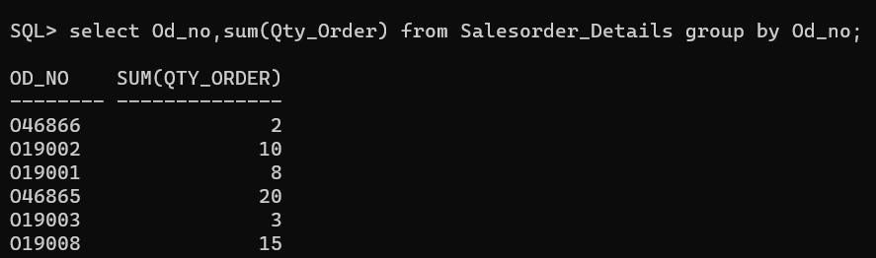

|  |
| --- |
|  |
| **Question Bank:**   1. What is Order By clause ? 2. Differentiate Union and Join |

# Practical No. 9

|  |
| --- |
| **Objective(s):**  To conclude the SQL topic with Miscellaneous Queries |
| **Outcome:**  The students will be able to understand and perform the different kind of DML queries and Join problems. |
| **Problem Statement:**  Implement the Miscellaneous Queries |
| **Background Study:**    All kind of queries like DML,DDL, Join, LIKE, Where clause with order by, group by. |

|  |
| --- |
| **Query (Student Work Area):**     1. Find the average rate for each Order. 2. Give the loan details of all the customers. 3. List the customer name having loan account in the same branch city they live in. 4. Provide the loan details of all the customers who have opened their accounts after August’95. 5. List the order information for client C00001 and C00002. 6. List all the information for the orders placed in the month of June. 7. List the details of clients who do not stay in Maharashtra. 8. Determine the maximum and minimum product price. Rename the output as “Max_Price” and   “Min_Price”.   1. Count the number of products having price less than or equal to 500. 2. List the order number and the day on which client placed an order. 3. List the month and the date on which an order is to be delivered. 4. List the date, 25 days after today’s date. 5. Find the total of all the billed orders in the month of June. 6. List the products and orders from customers who have ordered less than 5 units of “Pull Overs”. 7. Find the list of products and orders placed by “Ivan Bayrosss” and “Mamta Muzumdar”. 8. List the clients who placed order before June’04. 9. List all the clients who stays in “Bengaluru” or “Mangalore”. |

**Output (Student Work Area):**

**1)**

**Find the average rate for each Order.**

○

**Syntax:**

select Od_no, avg(Rate) from Salesorder_DetaiIs group by Od_no;

**2)**

**Give the loan details of all the customers.**

○

**Syntax:**

select * from Borrow;

**3)**

**List the customer name h**

**aving loan account in the same branch city they**

**live in.**

○

**Syntax:**

select C.Cname from Customers C, Branch B, Deposit D where

D.Bname=B.Bname and D.Cname=C.Cname and C.City=B . City;

**4)**

**Provide the loan details of all the customers who h**

**ave opened their**

**accounts after August'95.**

○

**Syntax:**

select D.Cname,C.City,D.Bname,D.Amount from Deposit D,

Customers C where C.Cname=D.Cname and D_date>’

2

0

-

AUG

-

95

’;

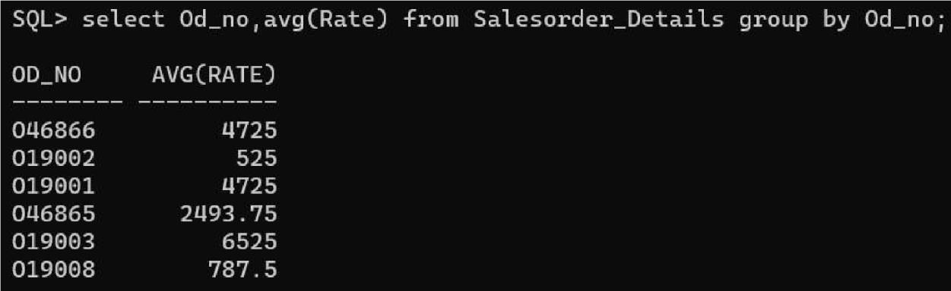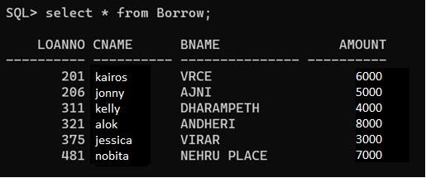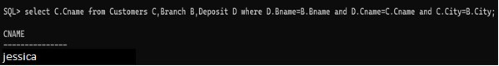

**5)**

**List the order information for client C0000I and C00002.**

○

**Syntax:**

select

O. * from Satesorder S inner join Satesorder_Detaits O on

S.Od_no=O.Od_no where S.Cl_no=’C00001’ or S.Cl_no=’C00002’;

**6)**

**List all the information for the orders placed in the month of June.**

○

**Syntax:**

select O. * from Salesorder S inner join Sal

esorder_DetaiIs O on where

S.D_Date like ‘%JUN%’;

**7)**

**List the details of clients who do not stay in Maharashtra.**

○

**Syntax:**

select * from Client where not State=' Maharashtra' ;

**8)**

**Determine the maximum and minimum product price. Ren**

**ame the**

**output as "Max_Price" and “Min_Price".**

○

**Syntax:**

select min(Cost_Price) Min_Price, max(Cost_Price) Max_Price from

Product;

**9)**

**Count the number of products having price less than or equal to 500.**

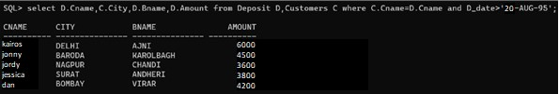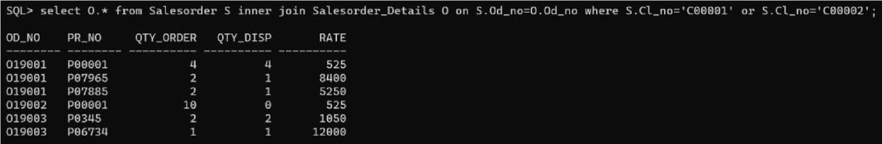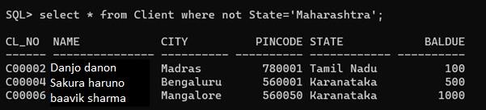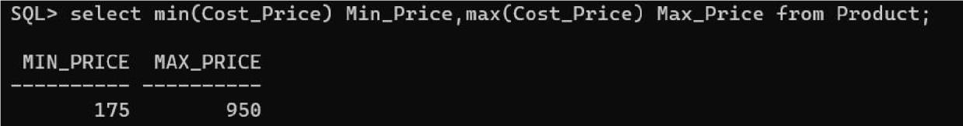

○

**Syntax:**

select count(*) from Product whe

re Cost_Price <= 500;

**10)**

**List the order number and the day on which client placed an order.**

○

**Syntax:**

select Od_no, O_date from Salesorder;

**11)**

**List the month and the date on which an order is to be delivered.**

○

**Syntax:**

select Od_no, ex

tract(month from D_date) Month , extract(day from

D_date) Day from Salesorder;

**12)**

**List the date, 25 days after today's date.**

○

**Syntax:**

select Od_no, avg(Rate) from Salesorder_DetaiIs group by Od_no;

**13)**

**Find the total of all the bil**

**led orders in the month of June.**

○

**Syntax:**

select count(Od_no) from Satesorder where O_Date like ‘%JUN%’

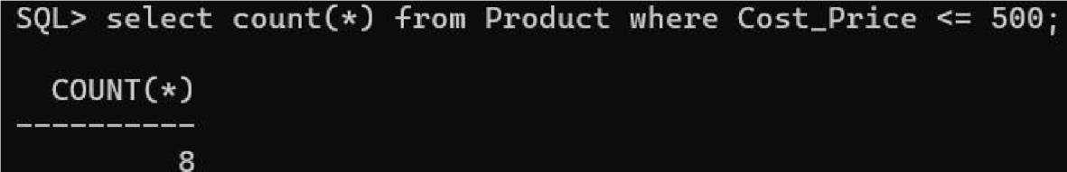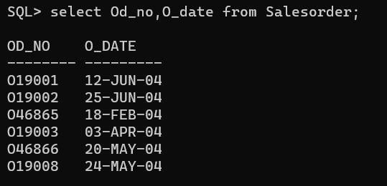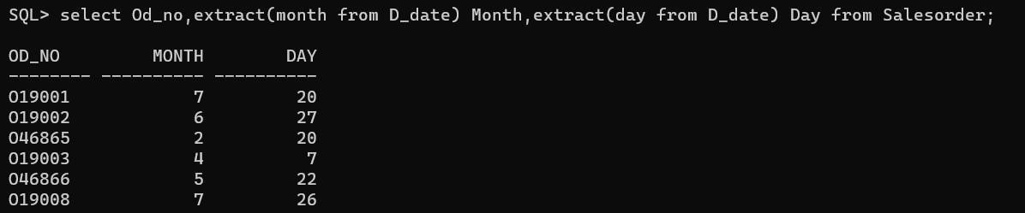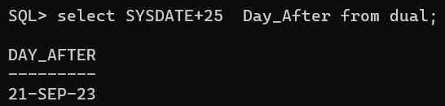

**14)**

**List the products and orders from customers who have ordered less**

**than 5 units of "Pull Overs".**

○

**Syntax:**

select O.Od_no,P.Dscr,C.Name f

rom Client C, Product P,

Satesorder S, Satesorder_DetaiIs O where C.CI_no=S.CI_no and

P.Pr_no=O.Pr_no and S.Od_no=O.Od_no and O.Qty_order < 5 and P.Dscr='

Putt Overs' ;

**15)**

**Find the list of products and orders placed by "Ivan Bayross" and**

**"Ma**

**mta Muzumdar".**

○

**Syntax:**

select distinct O.Od_no,O.Pr_no,P.Dscr,C.Name from Client C inner

join Salesorder S inner join Product P inner join Salesorder_DetaiIs O on

P.Pr_no=O.Pr_no on O.Od_no=S.Od_no on where C. Name:' Ivan

Bayross' or C. Name:' Mamta

Muzumdar' ;

**16)**

**List the clients who placed order before June'04.**

○

**Syntax:**

select C. Name from client C, Salesorder S where

S.CI_no=C.CI_no and O_date<’

12

-

JUN

-

04

’;

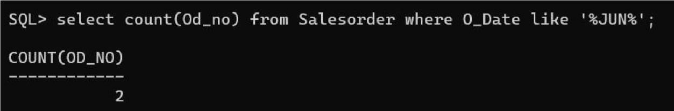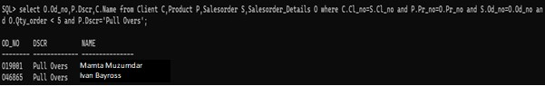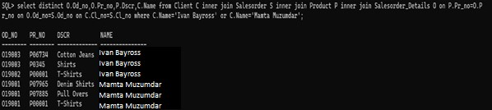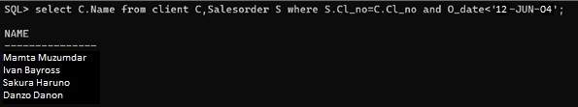

|  |
| --- |
| **17) List all the clients who stays in "Bengaluru" or "Mangalore".**   **Syntax:** select Name from Client where City: ' Bengaluru' or City: ' Mangalore'  ; |
| **Question Bank:**   1. If you want to find out the record of employees whose name is starting from ‘R’ which clause you will use ? write a syntax. 2. “Commit” command is used for 3. What is RQL? |

Practical No. 10

|  |
| --- |
| **Objective(s):**  To familiarize students with PL/SQL Block |
| **Outcome:**  The students will be able to understand and perform the PL/SQL Block |
| **Problem Statement:**    Implement the PL/SQL Block |
| **Background Study:**  In PL/SQL, All statements are classified into units that is called Blocks. PL/SQL blocks can include variables, SQL statements, loops, constants, conditional statements and exception handling. Blocks can also build a function or a procedure or a package.    **The Declaration section:** Code block start with a declaration section, in which memory variables, constants, cursors and other oracle objects can be declared and if required initialized.  **The Begin section**: Consist of set of SQL and PL/SQL statements, which describe processes that have to be applied to table data. Actual data manipulation, retrieval, looping and branching constructs are specified in this section.  **The Exception section:** This section deals with handling errors that arise during execution data manipulation statements, which make up PL/SQL code block. Errors can arise due to syntax, logic and/or validation rule. **The End section:** This marks the end of a PL/SQL block. |

|  |
| --- |
| **Query (Student Work Area):**     1. Write a PL/SQL Block to Add 2 Numbers 2. Write a PL/SQL Block to find Area of Rectangle, Triangle and Square 3. Write a PL/SQL Block to find Maximum of 3 numbers 4. Write a PL/SQL Block to print sum of N Numbers using For Loop 5. Write a PL/SQL Block to generate Fibonacci series of N numbers |
| **Output (Student Work Area): 1)** Write a PL/SQL Block to Add 2 Numbers.      **2)** Write a PL/SQL Block to find Area of Rectangle, Triangle and Square.     Area of Rectangle: |

○

Area of Triangle:

○

Area of Square:

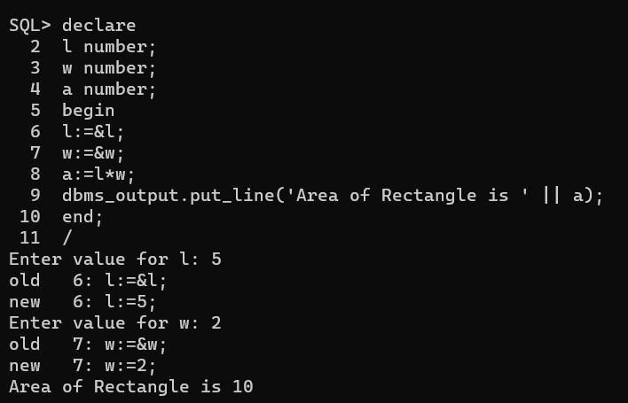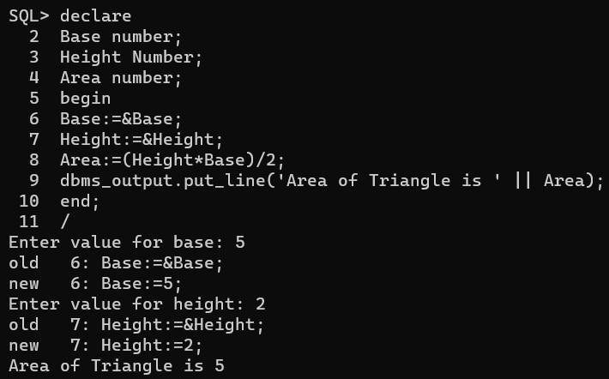

**3)**

Write a PL/SQL Block to find Maximum of 3 numbers.

**4)**

Write a PL/SQL Block to Add 2 Numbers.

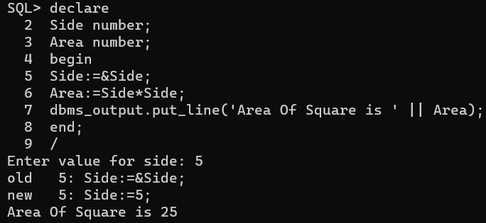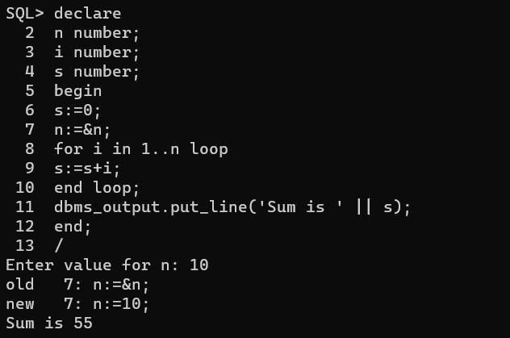

**5)**

Write a PL/SQL Block to generate Fibonacci series of N number

s.

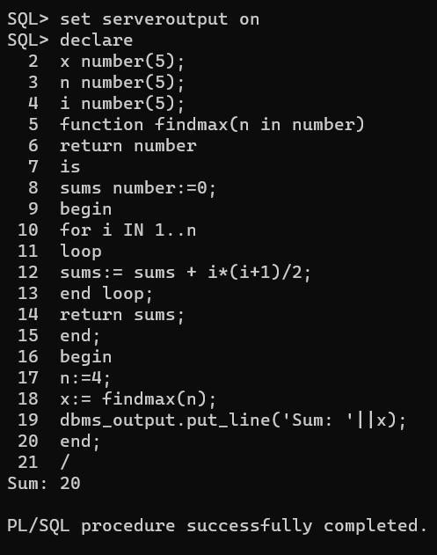

|  |
| --- |
|  |
| **Question Bank:**     1. What is PL/SQL? Explain it in brief. 2. How to declare a variable into PL/SQL? |